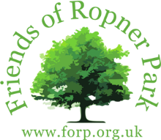
Park Trail 2025

12 noon. Sunday 28th September 2024
Ropner Park, Stockton on Tees
Distance approx. 3km
Adults: £3.50 Children: £2.00
Donations, if preferred, can be made on the day.
Registration: 11.50am at the rear of the park café
Soup and a bread roll will be served at the end of the walk

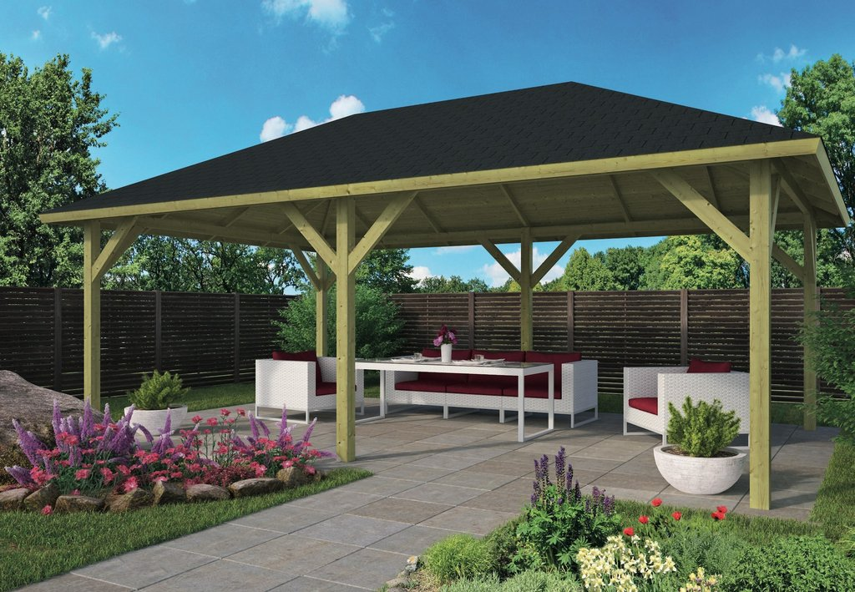

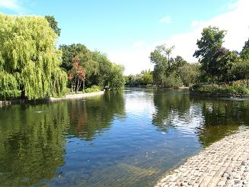
The Friends of Ropner Park are embarking on a fund-raising campaign to provide an outdoor seating area at the front of the café. This will enable dog walkers and others to use this much needed sheltered space when enjoying food and drinks.
Please come along and help us to start our journey to raise the funds required to achieve this.

Registered Charity No: 1125093

